

**CIA4U**

**Lesson 1.4 Supply and Demand Assessment**

**Type of Assessment: Homework**

**Purpose of Assessment: Assessment FOR Learning**

**Method of Assessment: Yes/No**

**Learnings Goals:**

* Students will demonstrate an understanding of models of supply and demand, including price elasticity, and apply these models to analyse selected economic decisions
* Students will explain how various factors, including taxation, affect supply and demand
* Students will use supply and demand models to analyse consumer decision making

|  |  |
| --- | --- |
| **Fundamentals of Economics** | B2 Supply and Demand Models: demonstrate an understanding of supply and demand models, including how to apply these models, and of factors that affect supply and demand. |

|  |  |
| --- | --- |
| **Ontario Curriculum Expectations** | |
| **B2.1** | demonstrate an understanding of models of supply and demand, including price elasticity, and apply these models to analyse selected |
| **B2.2** | explain how various factors, including taxation, affect supply and demand |
| **B2.3** | use supply and demand models to analyse consumer decision making |

**Instructions:**

1. For each of the following, explain what would happen to price, quantity and why.
   1. A new strain of wheat was discovered, which raised yield.
   2. The United Grain Growers organized an extensive advertising campaign.
   3. The government implemented a tax on each unit of wheat sold.
   4. It was proven that a regular diet of flaxseed, rather than wheat, lengthens life.
   5. Consumers who turn down beef and pork are faced with rising prices for substitute protein products, such as eggs, cheese, and poultry.
2. Is demand for the following elastic or inelastic? Why?
   1. Big Mac
   2. Salt
   3. Brain surgery
3. For each type of demand, identify a product and explain one reason for the demand:
   1. elastic
   2. inelastic
   3. perfectly elastic
   4. unitary elastic
4. Explain the meaning of the following cartoon, using supply and demand.

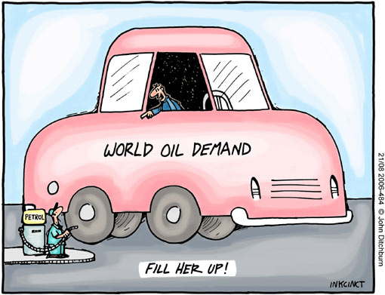

by [John Ditchburn](https://userscontent2.emaze.com/images/76de4731-836c-4706-83af-e1589857035f/9742e50da2d22862172c7538433747b2.jpg)

1. The market for beef busily minds its own business when suddenly, it is faced with a significant, successful advertising campaign by pork producers. Caught by surprise, the beef market responds with a price war that becomes excessive, as it lasts too long. (Assume pork and beef are substitutes for this problem.)
   1. Sketch and explain in detail the graph of the original market for beef, then show and explain the impact of the pork advertising campaign.
   2. Explain the impact of the pork advertising campaign on beef farmers, grocery stores, and consumers (beef and pork).
   3. Assume the beef farmers panic and ask the federal government for assistance. What advice would you give the government and explain using economic thinking concepts of cause and effect, economic perspective, and stability and variability?
   4. What advice would you give the beef farmers? Explain with a graph as well as your explanation

**Submit your assignment in your shared course folder.**